## Figure Captions



Figure 1. Faga'alu watershed showing the Upper (undisturbed) and Lower (human-disturbed) subwatersheds. The Lower subwatershed drains areas between FG1 and FG3, and is further subdivided into the Lower_Quarry containing the quarry (between FG1 and FG2) and the Lower_Village containing the village areas (between FG2 and FG3). The Total watershed includes all subwatersheds draining to FG3. The Administrative watershed boundary for government jurisdiction is outlined by the dotted grey line. Blue pentagons in the Upper watershed show the location of abandoned water supply reservoirs (see Appendix A for full description). Barometer locations at NSTP6 and TULA are shown in top-right.



Figure 2. Photos of the aggregate quarry in Faga'alu in 2012, 2013, and 2014. Pictures a-b show vegetation overgrowth during the period of study from 2012-2014, and the location of the groundwater diversion that was installed in 2012. Pictures c-d show that haul roads were covered in gravel in 2013. Photos: Messina

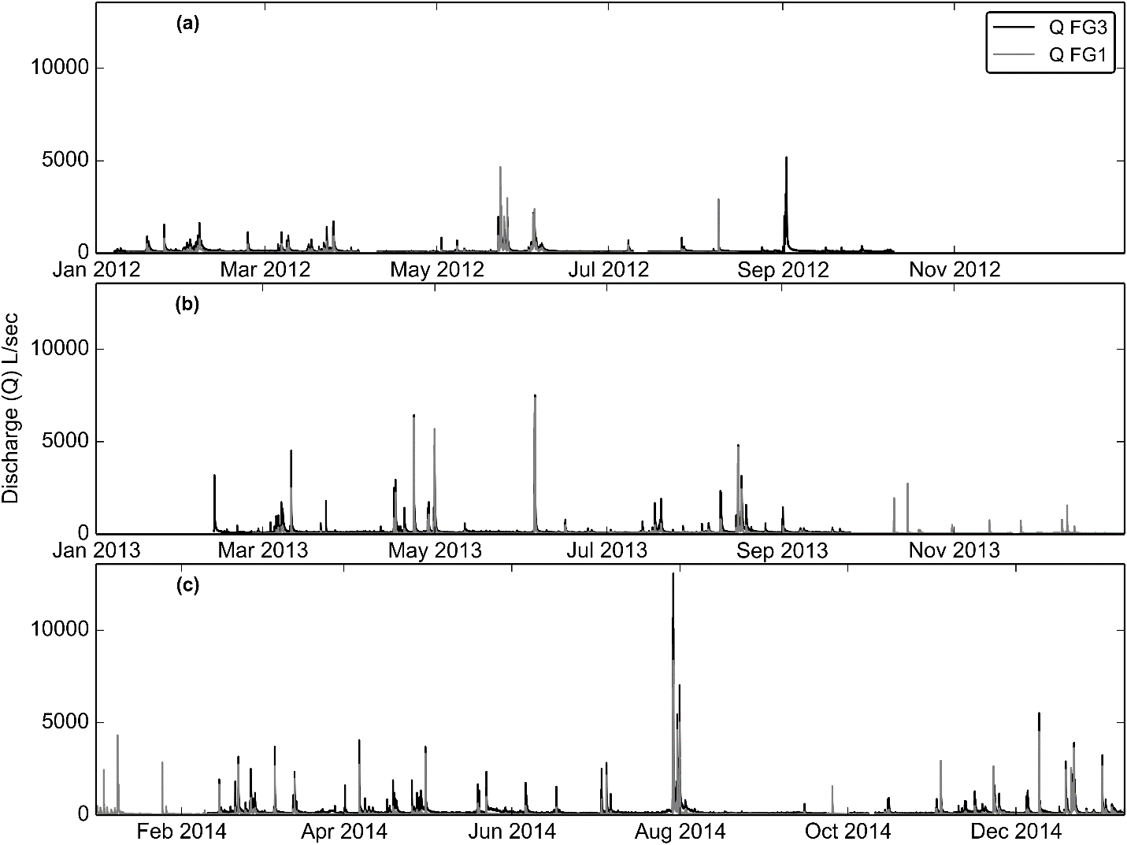

Figure 3. Time series of water discharge (Q) at FG1 and FG3, calculated from measured stage and the stage-discharge rating curves in a) 2012 b) 2013 and c) 2014.

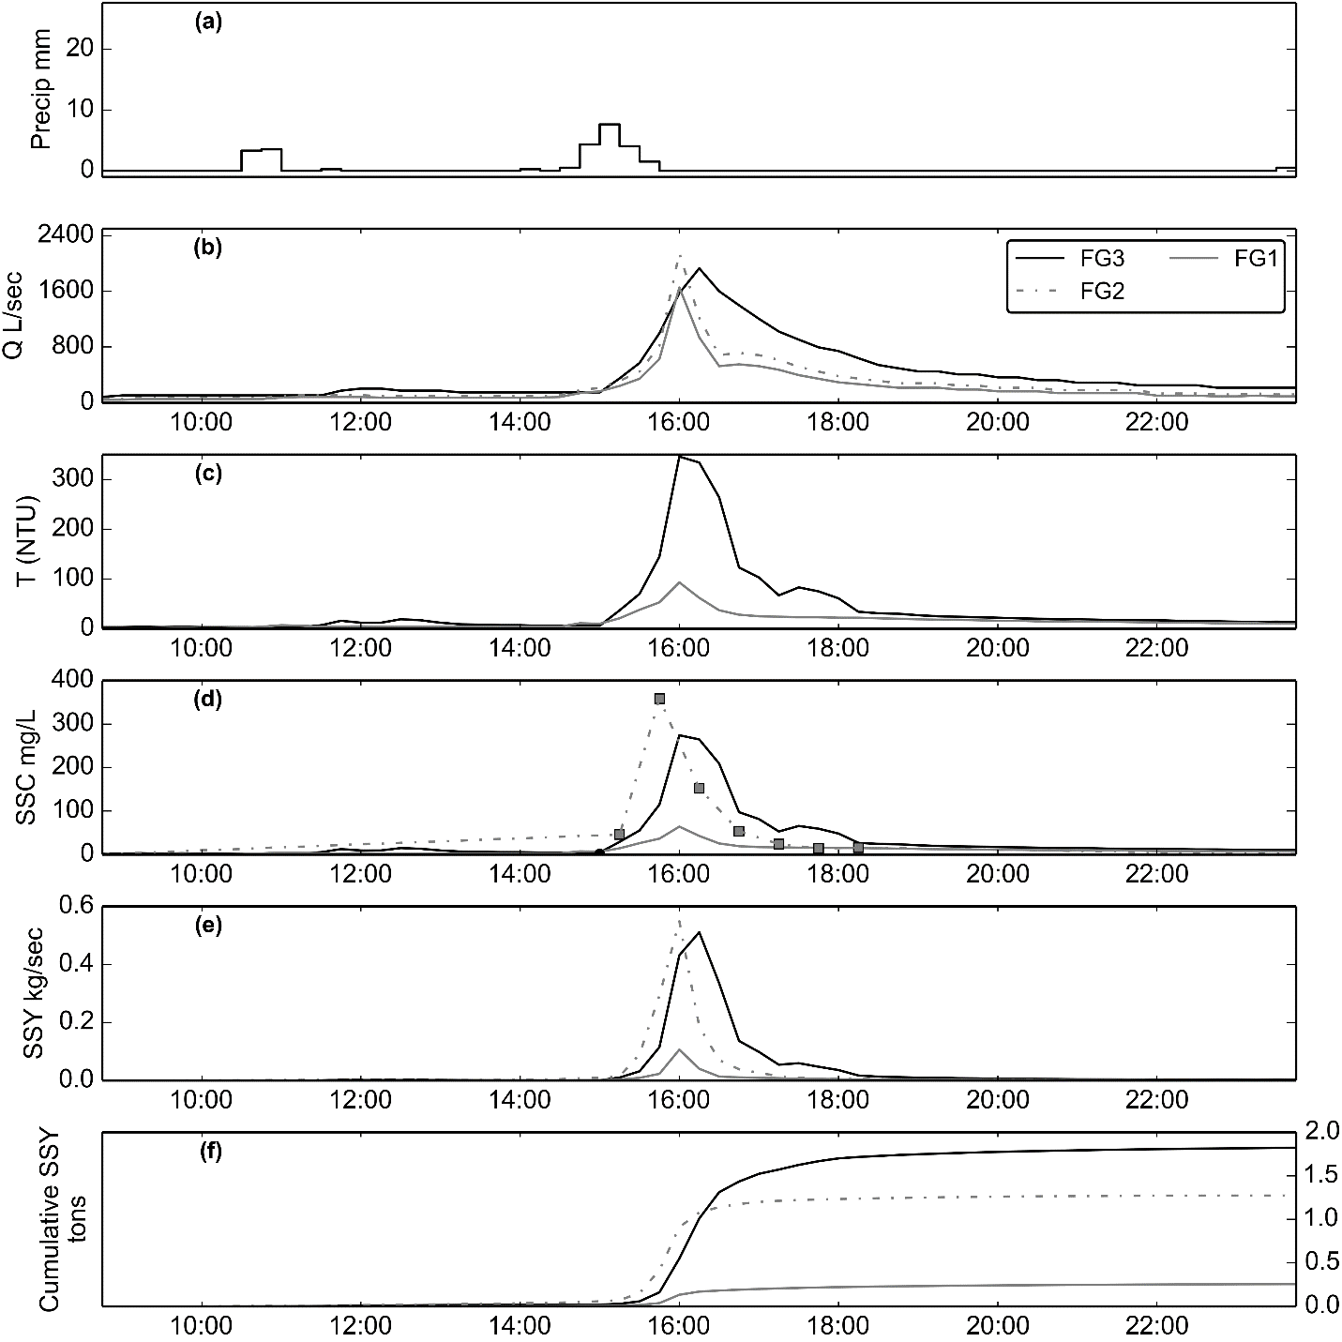

Figure 4. Example of a storm event (02/14/2014). SSY at FG1 and FG3 calculated from SSC modeled from T, and SSY at FG2 from SSC samples collected by the Autosampler.

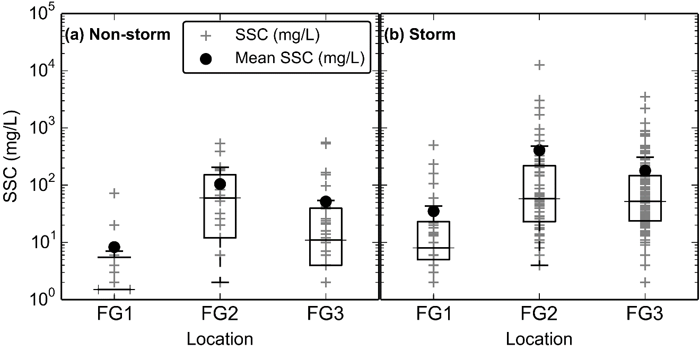

Figure 5. Boxplots of Suspended Sediment Concentration (SSC) from grab samples only (no Autosampler) at FG1, FG2, and FG3 during (a) non-stormflow and (b) stormflow.

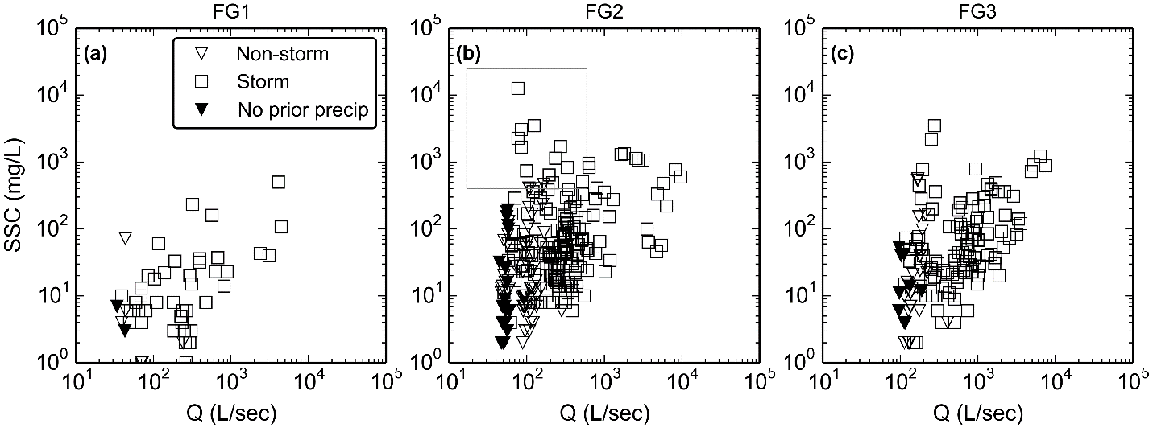

Figure 6. Water Discharge (Q) versus suspended sediment concentration (SSC) measured from stream water samples at a) FG1, b) FG2, and c) FG3 during non-stormflow and stormflow periods. The box in b) highlights the samples with high SSC during low flows. Solid symbols indicate SSC samples where precipitation during the preceding 24 hours was 0 mm.

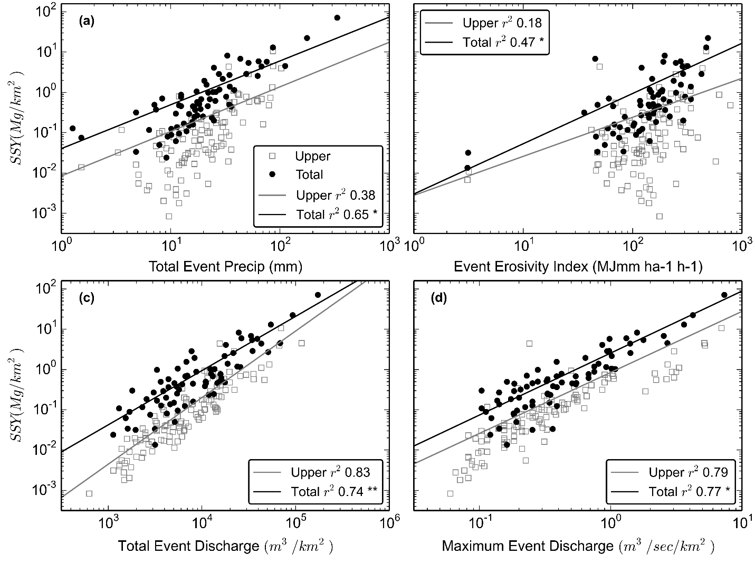

Figure 7. sSSYEV regression models for predictive storm metrics. Each point represents a different storm event. **=slopes and intercepts were statistically different (p<0.01), *=intercepts were statistically different (p<0.01).

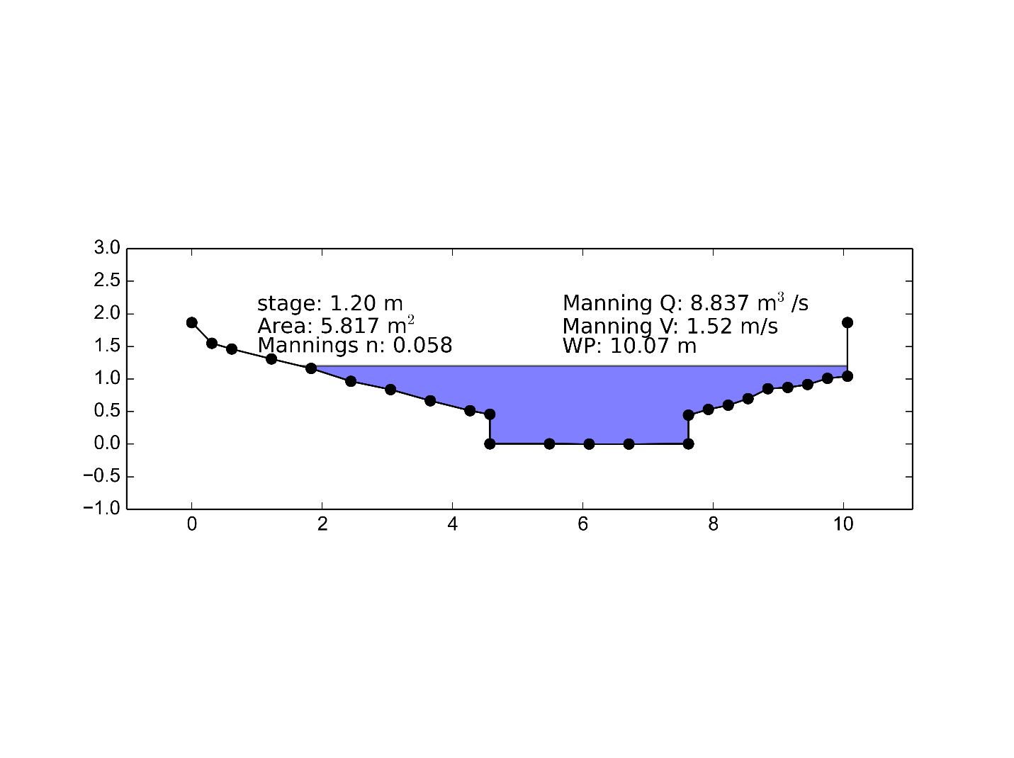

Figure B.1. Stream cross-section at FG1

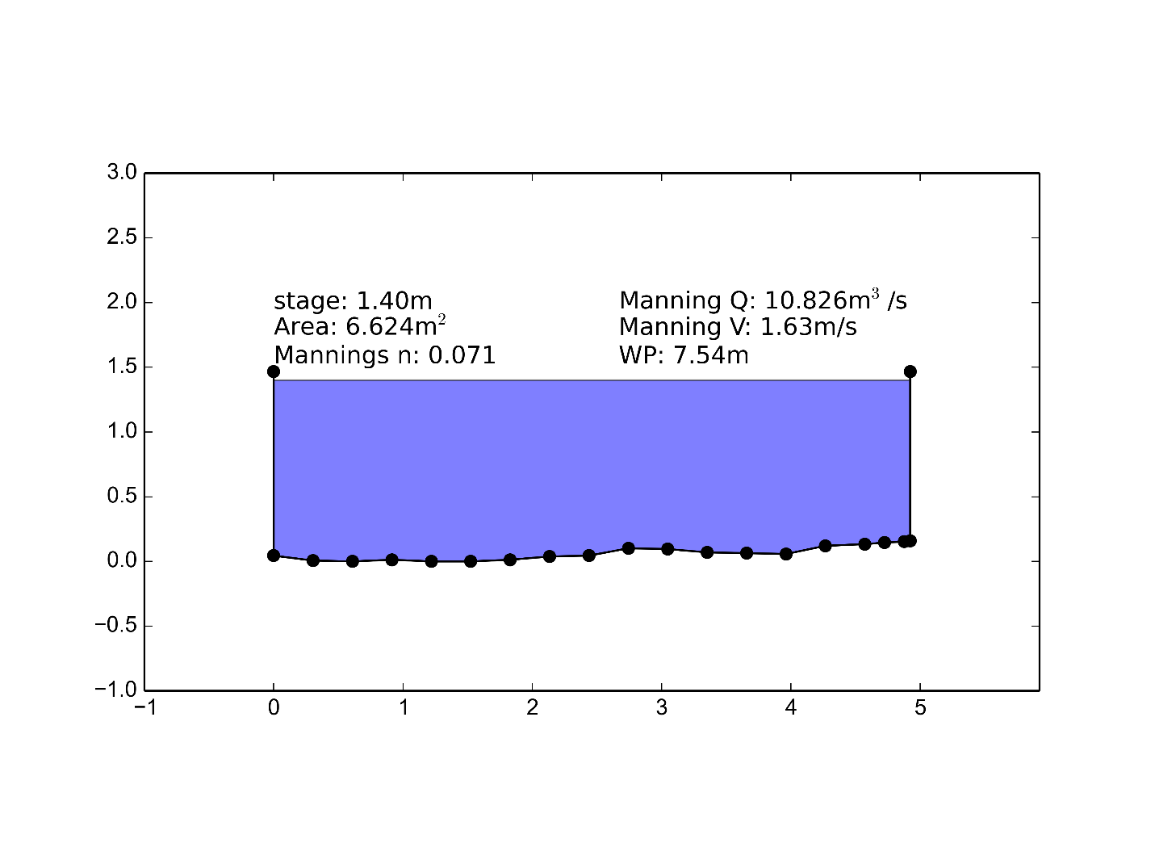

Figure B.2. Stream cross-section at FG3

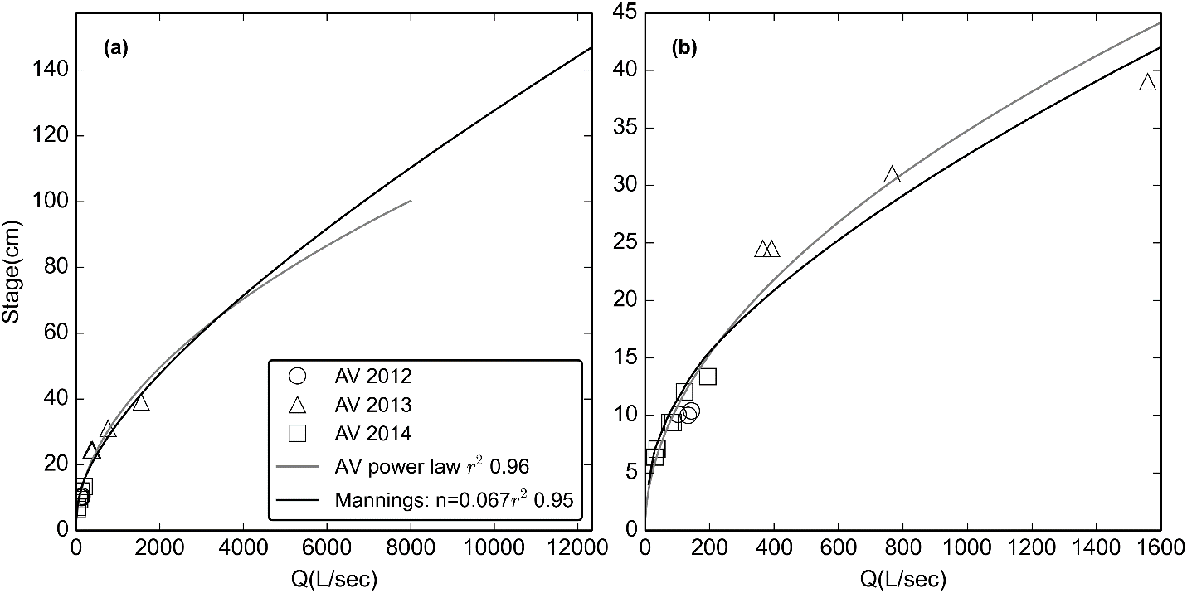

Figure B.3. Stage-Discharge relationships for stream gaging site at FG3 for (a) the full range of observed stage and (b) the range of stages with AV measurements of Q. RMSE was 93 L/sec, or 32% of observed Q.

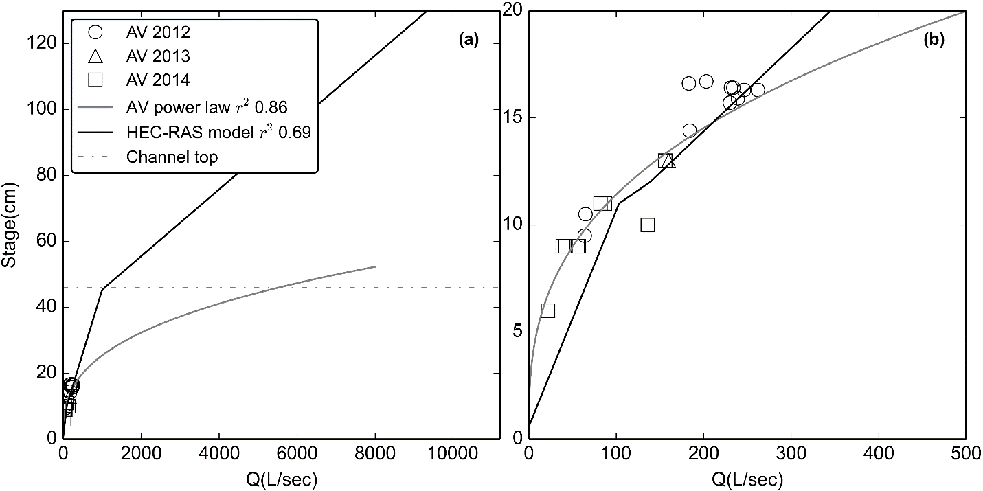

Figure B.4. Stage-Discharge relationships for stream gaging site at FG1 for (a) the full range of observed stage and (b) the range of stages with AV measurements of Q. RMSE was 31 L/sec, or 22% of observed Q. "Channel Top" refers to the point where the rectangular channel transitions to a sloped bank and cross-sectional area increases much more rapidly with stage. A power-law relationship is also displayed to illustrate the potential error that could result if inappropriate methods are used.

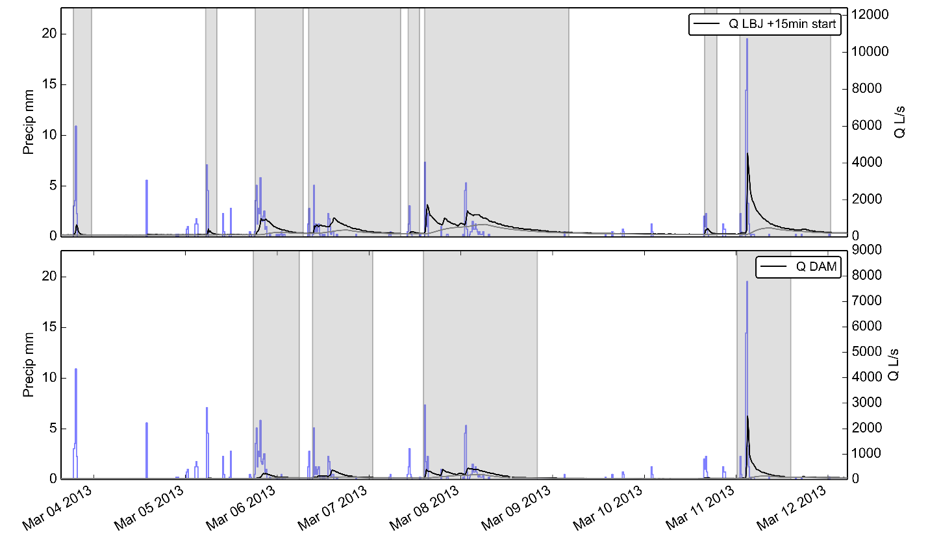

Figure C.1. Example of method for separating storms based on baseflow separation. Black line is hydrograph, grey line is baseflow calculated by R statistical package EcoHydRology. Storm periods are shaded in grey. Seven storm events are identified from March 3, 2013 to March 13, 2013.

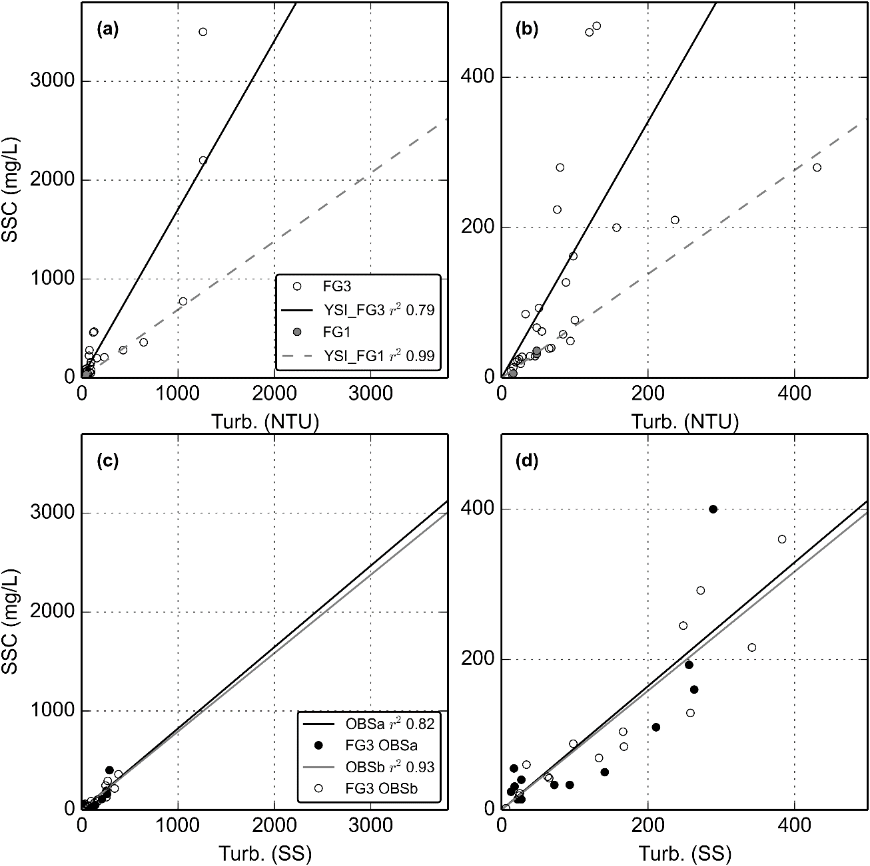

Figure D.1. Turbidity-Suspended Sediment Concentration relationships for a-b) the YSI turbidimeter deployed at FG3 (02/27/2012-05/23/2012) and the same YSI turbidimeter deployed at FG1 (06/13/2013-12/31/2014)(Same T-SSC relationship applied for TS deployed at FG1). c-d) OBS500 turbidimeter deployed at FG3 (03/11/2013-07/11/2013) and the same OBS500 turbidimeter deployed at FG3 (01/31/2014-03/04/2014).

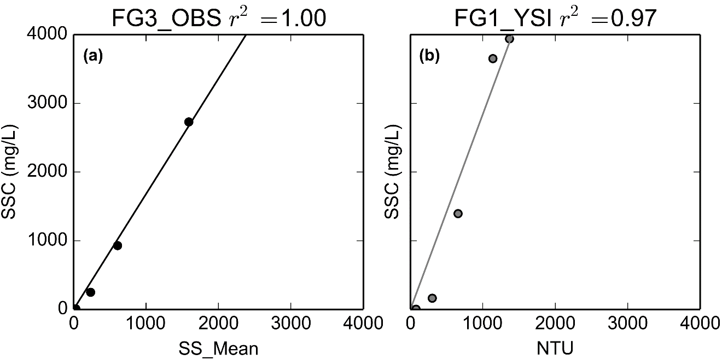

Figure D.2. Synthetic Rating Curves for (a) OBS turbidimeter deployed at FG3 and (b) YSI deployed at FG1.